**Evelander**

Low-Fi Prototyping & Pilot Usability Testing

Authors and Roles:

Anas Khalid Kayani: Team Manager

Muhammad Ahmer: Design: Usability Testing

Mohabbat Ali: Programming

Hajir Abdul Rehman: Software Engineer

**Mission Statement:**

Managing events made easier

**Problem/Solution Overview**

There are many events happening around us on the daily basis. But there is a communication gap between the attendees and organizers. Many people would like to go and most of those even join these events. For publically announcing an event organizers and event managers use Facebook, Instagram, Twitter and other such platforms. These social platforms are not specifically for events only. Top of these platforms is Facebook. Almost every event is publically announced on it. But the issue is only those people can see the event ad who are following the page or if the page admin use boosters (which are paid) to spread the event. Means that if a page has 500 followers, so only around 500 on people would get to know about it, even if the event is worth attending and there would be thousands of others waiting for such events. So the problem is that people missed crazy and special events because they “didn’t knew” about it. There is a gap between the attendees and the organizers that’s need to be fulfilled.

**Evelander** is an android application that will solve all the problems of both organizers and attendees. Evelander is a multi-purpose app that will allow you to locate all the events happening near you. There will be different categories like sports, textile, media, arts, expos, travel, etc. You can select multiple categories of our interest. Only those events will be appeared on your home screen which you have added in your interests. You can add any of those events in your favourites or going list. The events will have a short description, includes timing, date, day and venue. A short reminder will appear on the day of the event or as you want. Secondly the event schedule and any update in the event will be done simultaneously. Cancellation of the event or any update will be provided by the online/offline text. There will be an additional option of chatting with the organizers. You can rate any event and provide your valuable reviews which will help the organizers to improve their events and remove their flaws.

**Sketches**

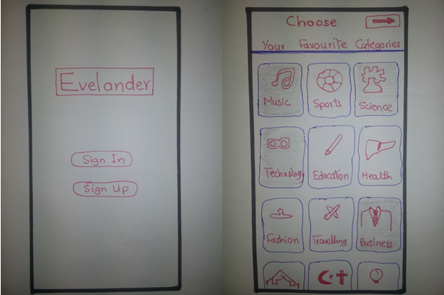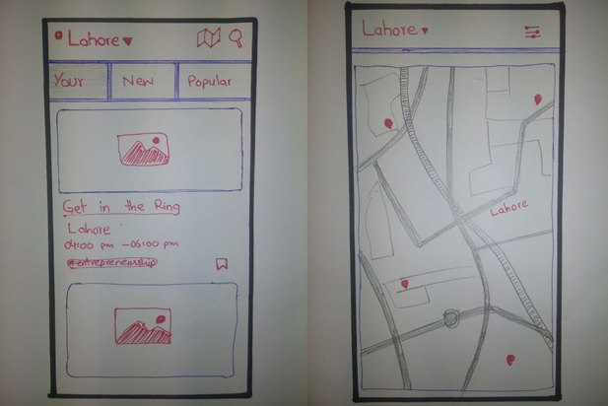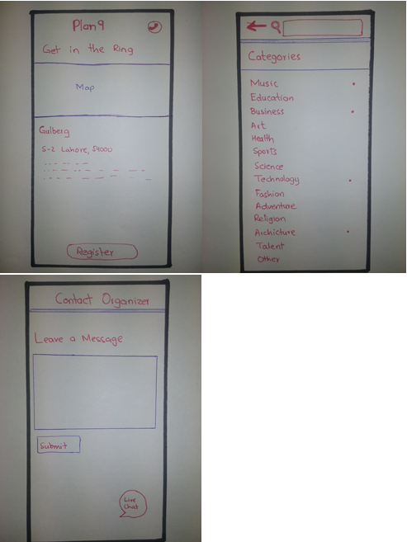

**Mobile app design**

|  |  |
| --- | --- |
| **Pros** | **Cons** |
| * People need notifications for events * They want one time registration * Can buy tickets from application * Will be notified on changing of event at the run time * Simple UI, straight to point * Quick process to access to any event * Organizer want targeted customers | * Most number of notifications may irritate users |

After evaluating the pros and cons of our top two designs, we decided to go with the mobile app design for our low-fidelity prototype. This was due to fact that most people use smartphones and don’t have time to looks up for their interested event on Facebook. These designs were chosen after the need-finding process.

**UI story boarding for, Simple, Moderate and complex Tasks**

**Our Prototype**

For our prototype we folded a piece of paper to emulate a standard mobile device. We then created multiple scenes out of paper that would emulate every screen of our app

**Method**

**Participants:**

We met people with different demographics and diverse set of the people at their places and ask them about the events organizing and attending different events. We were focused on the organizers who want their targeted audience and people who want to get notify of the events of their interest. They all were happy to take part in this without any compensation.

Participant # 1: We met Participant # 1 at his office while he was working on upcoming event. He was a computer science graduate.

Participant # 2: We met Participant # 2 at university while he was sitting in a university café and eating lunch we catch him up and talk to him. He is doing graduation in CS.

Participant # 3: We met participant# 3 at his office and talk to him. He is graduated in Political sciences.

**Environment:**

We did not take the picture of environment as it was not the event. That was offices of the people or their personal spaces.

**Tasks:**

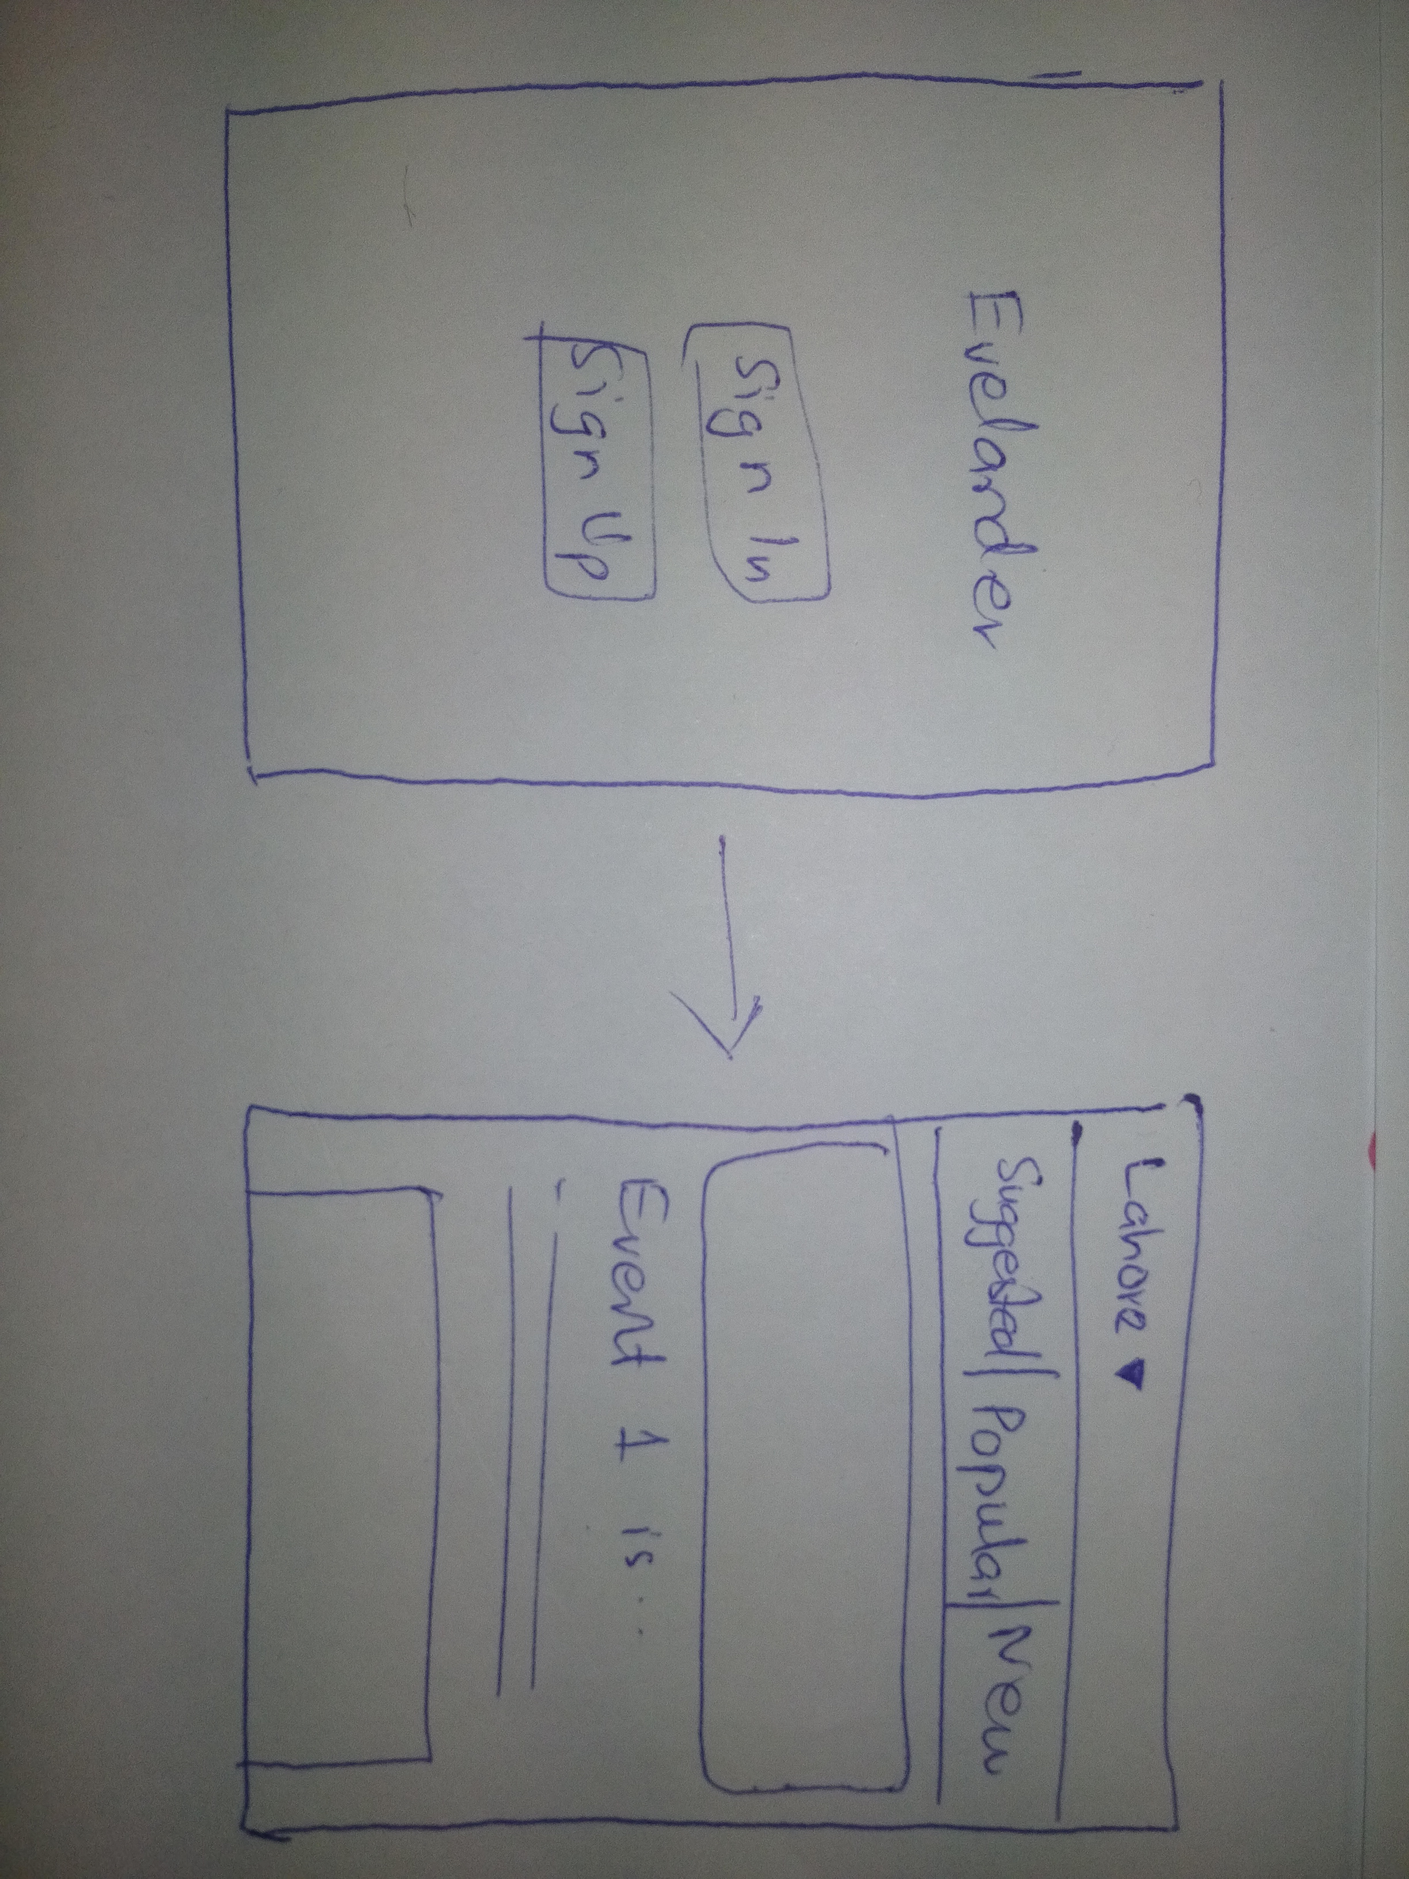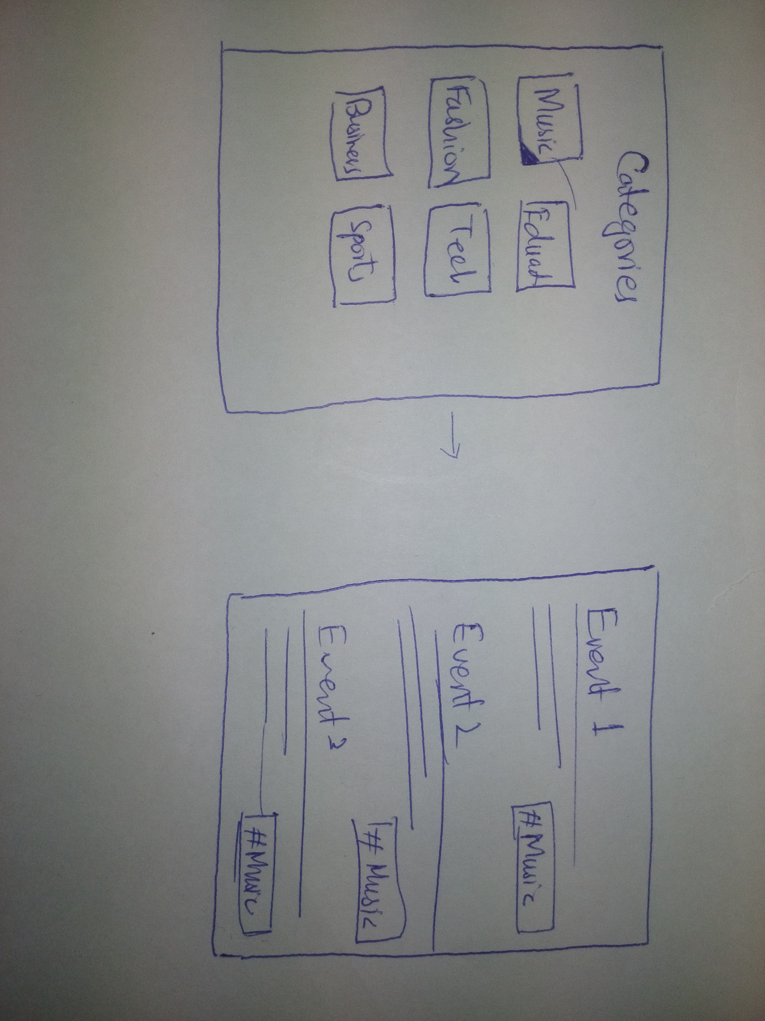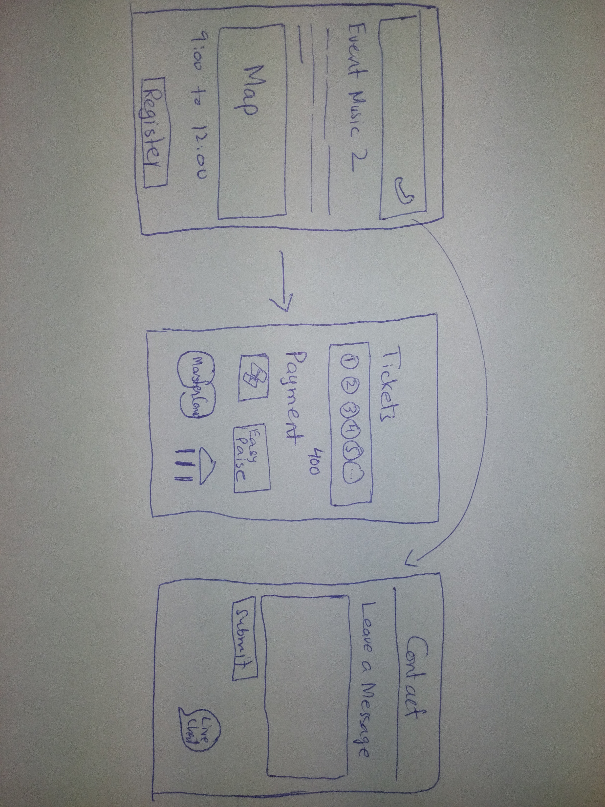

**Procedure:**

For each participant, we introduced ourselves and explained our project and what we were trying to accomplish, next, Ahmer told them how to interact with the paper prototype and explained that they should speak aloud while they do it.

**Task measures**

1. **Understanding of interface of an application that** user can understand easily what the application is all about and how to deal with different options
2. **Waiting of a person for looking for specific option** so that he can find his desired and particular option in how much that we need to improve our app buttons placement or not.
3. **Unexpected and Expected Clicks** that when making our prototype, there was a clear user flow that we believed should be followed for each task. We wanted to keep track of the number of times the user deviated from what we expected them to do. This includes clicking on buttons that we didn’t expect them to click on or not clicking on buttons that we expected them to click on.

**Results:**

**Participant 1:**

Participant 1 was happy as he was the organizer and he wanted to have targeted audience so that they can arrange the event for those people, and that can play an important role to get their sponsors, who actually want to have customers. He said the interface is clear and easy to understand for me to register any event.

**Participant 2:**

Participant 2 was an attendee who is enthusiast wander boy and attends events, he said that he really wanted that type of applications so that he did not have to keep track of every event and he will get notified for events. Otherwise he have to search for event at Facebook which costs him time and sometime payment have been paid at bank account with which he missed many events that he don’t want to go to bank as he is a student.

**Participant 3:**

This participant was a private job holder and when we talk to him he said that I get irritate by Facebook notifications then why will I use your app that will notify me for very event. Which made us think to add an option to get notify for event after they selected going or not. He was happy with that he get notified once before sometime to go to that event.

**Discussion:**We were pleased with the participants that used our prototype as we believe there are representative of the target demographic. It was comforting to know that they each stated that they would use this app for organizing and attending events.

People get irritate to get notify for every event and that was our observation after being testify them our prototype and we come to conclusion that we should think to add an option to get notify for event after they selected going or not.

People wanted to buy tickets from our app rather than go to bank for money transfer or any shop. We needed to edit these thing and do these things after the observation from people.

**Appendix**

**Script**

Introduction:

Thank you for volunteering your time to try the demo of our app, Evelander. Our app is designed to make shopping easier for customers by using Augmented Reality to enhance their shopping experience. We will ask you to do a series of three tasks with our app. Please sign this consent form before we begin.

Gather Info:

What is your name? Where are you from? What is your occupation? What brings you here today?

Directions:

This is a low fidelity prototype of what our app could potentially look like. Please interact with our paper prototype as if it was your own personal smartphone. One of us will act as the “computer” in your phone as you navigate your way through our app. While using the app, please think out loud as it will help us gauge your experience, which will be helpful towards our development of this product.

I will provide a demonstration of our app flow and how we describe it.

Demo:

(display app with login screen) “This looks like a login page. I will click login to get into the app” (transition from login page to page with scan view) “What happens if I swipe from the left side of the screen” (Display sidebar) “Oh cool looks like a settings tab of some sort”

Simple Task

● Browsing suggested events

Moderate Task

● looking for events of your choice

Complex Task

● finding details of a particular event, contacting the organizer and buying the ticket.

**Notes:**

All of the users were very well aware of the smart phone and were not find it difficult to use.

**Participant 1:**

* Searching for login as it was at the top of the screen, we moved it in the center
* Excited to know about their targeted audience
* Questioned how we are sure about that the audience is 100% sure that they will come

**Participant 2:**

* He was happy and get to know about the feature easily
* First time he takes time to look things up.

**Participant 3:**

* He find it useful when we said it have option to notify if you want
* Suggestions to make better UI design.

**Consent Form**

The Android application is being produced as part of the coursework for Computer Science course CS 411 at Information Technology University. Participants in experimental evaluation of the application provide data that is used to evaluate and modify the interface of Evelander. Data will be collected by interview, observation and questionnaire.

Participation in this experiment is voluntary. Participants may withdraw themselves and their data at any time without fear of consequences.

Participant anonymity will be provided by the separate storage of names from data. Data will only be identified by participant number. No identifying information about the participants will be available to anyone except the student researchers and their supervisors/teaching staff.

I hereby acknowledge that I have been given an opportunity to ask questions about the nature of the experiment and my participation in it. I give my consent to have data collected on my behavior and opinions in relation to the Evelander. I also give permission for images/video of me using the application to be used in presentations or publications as long as I am not personally identifiable in the images/video. I understand I may withdraw my permission at any time

Name ______________________________________________

Participant Number ____________________________________

Date _______________________________________________

Signature____________________________________________

Witness name ________________________________________

Witness signature_____________________________________